- SA 2021-22  ARCH-P-7115  These design studies are applied in the frame of links with building material federations. |  | Structure & Architecture  Architectural Design & Construction  Competition  nnnFocus 2021  Focus 2021  Reimagine  concrete  Martin Geneviève  Place Flagey 19, Fl.4.7.  1050 Brussels  +32 (0)2 639 24 29  genevieve.martin@ulb.be  First Term  Thursdays 9-12 am & 2-6 pm

Objectives of this teaching unit
- This unit “Architectural Design and Construction” offers the ability to formulate and criticize the mechanical functioning of building structures, and to assess the specific issues raised by the design of a structure with a view to making reasonable, coherent, and rational choices.
- Also, we push to evaluate the technical and constructive principles, to analyse and use technical documents and to dialogue professionally with the engineer based on rigorous structural reflexivity.

Our contribution to the educational profile
- Design a project to experiment and be innovative with a proposal including the integration of human, technical and economic constraints of the design project.
- Develop a reflexive attitude enriching the theories and practices of architecture: master and integrate the technical and human sciences of architectural design, manufacture, and transmit a design expertise, problematize a research question around the process.
- Build as an architect ethical and responsible practice: consider architecture as a cultural discipline constantly renewed, in constant touch with developments of artistic and social practices.
- Interact with all the actors involved in the issues of space and architecture: Foster experimentation and creativity; communicate in a clear and structured way for experienced or not public, the architectural design process tracking and its spatial production.

Course Outline > Learning Objective

Observe, analyse and assess the building process;
Assess the potential of a material and a design element;
Design and present an architectural project orally and in writing (book, article);
Participate to a competition;
Present in English (posters, book).
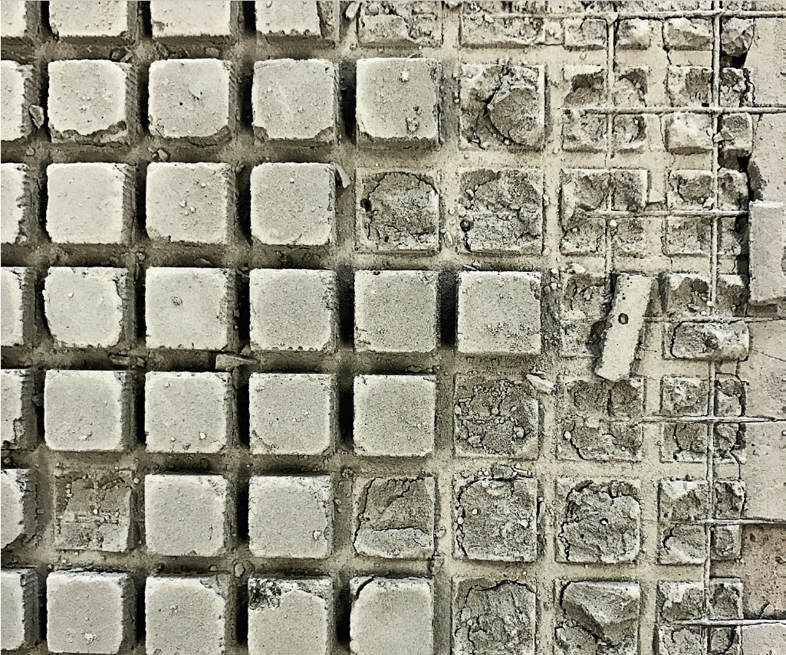

Statement for this semester 2021 > REIMAGINE
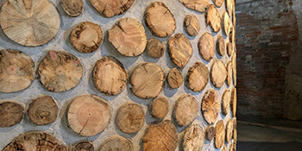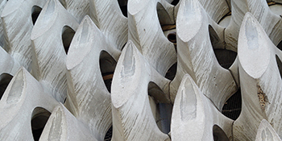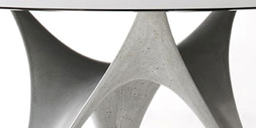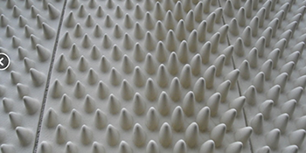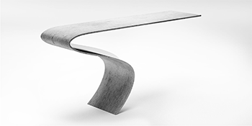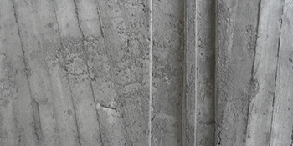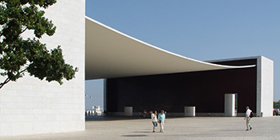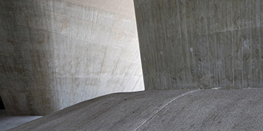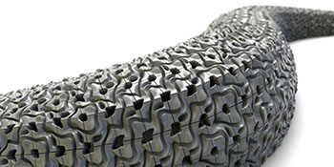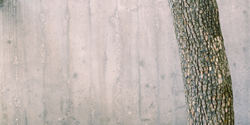

The 10th Concrete Design Competition on REIMAGINE asks students of architecture, design and engineering to explore and exploit the potential of concrete’s properties with respect to any notion of REIMAGINE. These can be related to inherent material properties, concrete’s production process, and its application in new or existing structures. They may address aesthetic desires, structural systems or fabrication methods and comment on economic realities, sustainability demands or social issues. In the past: 2019 Form-works, 2018 Wood in Europe, 2017 Concrete & Tactility, 2016 Paper & Wood in Light.

Prof. ir.Geneviève Martin genevieve.martin@ulb.be
Teacher in Mechanic, Building’s structure and equipment since 1992 at Victor Horta Architecture School. Researcher in Architectural Design Process. Cognitive Sciences, Faculty of Psychology and Education Sciences, ULB-ULg. Civil Engineer in Mechanic and Electricity (Fluid Mechanics), ULB.

