SA « Structure et Architecture »

« Architectural Design and Construction »
SA1_ARCH-P-7115 Module 1 Research & Development
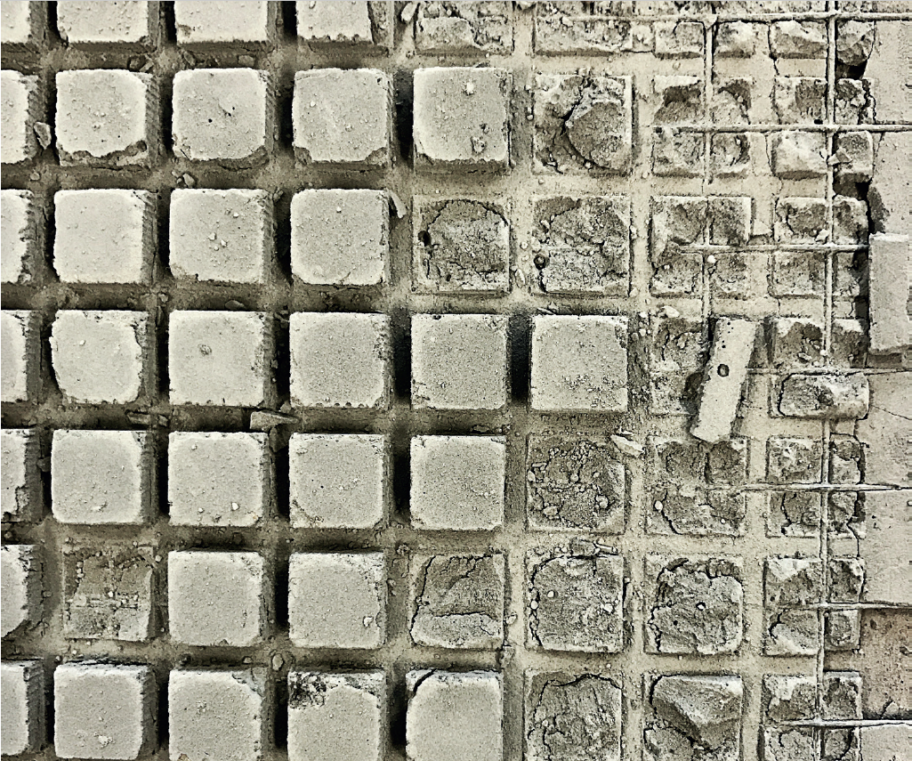
Philosophie de l’option
Philosophy of this teaching unit

- L’unité SA est conçue pour donner aux étudiants une vue d’ensemble des aspects de la construction en architecture. Elle développe une compréhension générale des termes techniques pour faciliter la communication dans la construction et l’industrie du bâtiment.
- SA Unit has been designed to provide students with an overview of different aspects of construction in architecture. It develops a general understanding of technical terms to help facilitate communication across the construction and building industry.

Objectifs du module et compétences visées
Objectives of this teaching unit and acquired specific learning

- This unit “Architectural Design and Construction” offers the ability to formulate and criticize the mechanical functioning of building structures, and to assess the specific issues raised by the design of a structure with a view to making reasonable, coherent, and rational choices.
- Also, we push to evaluate the technical and constructive principles, to analyze and use technical documents and to dialogue professionally with the engineer based on rigorous structural reflexivity.

Our contribution to the educational profile
- Design a project to experiment and be innovative with a proposal including the integration of human, technical and economic constraints of the design project.
- Develop a reflexive attitude enriching the theories and practices of architecture: master and integrate the technical and human sciences dealing with the process of architectural design, manufacture, and transmit a design expertise, problematize a research question around the process.
- Build as an architect ethical and responsible practice: consider architecture as a cultural discipline constantly renewed, in constant touch with developments of artistic and social practices.
- Interact with all the actors involved in the issues of space and architecture: Foster experimentation and creativity; communicate in a clear and structured way for experienced or not public, the architectural design process tracking and its spatial production.
Specific objectives
- SA1 : Observe, analyse and assess building process; Assess the potential of a material and a design element; Design and present an architectural project orally and in writing (book, article); Participate to a competition; Present in English (posters, book).

Enoncé(s) pour ce quadri

Statement for this term : ”REIMAGINE”
The 10th Concrete Design Competition on REIMAGINE asks students of architecture, design and engineering to explore and exploit the potential of concrete’s properties with respect to any notion of REIMAGINE. These can be related to inherent material properties, concrete’s production process, and its application in new or existing structures. They may address aesthetic desires, structural systems or fabrication methods and comment on economic realities, sustainability demands or social issues.

In the past
- 2019 Form-Works
- 2018 Wood in Europe
- 2017 Concrete & Tactility
- 2016 Paper & Wood in Light

Méthodologie - Methodology

Lectures, articles, interactive pedagogy, content and language integrated learning, attendance to students’ competition. SA is applied in the frame of links with building material federations.And others...

Enseignant - Teacher

Prof. ir.Geneviève Martin

genevieve.martin@ulb.be

